Nishant Jinsiwale

Disney-MSI, Burbank

**Git-hub Tutorial**



Table of Contents

Introduction : 3

Features and benefits of Github : 3

Terminologies : 3

Benefits : 4

Lifecycle 5

Environment setup 6

Create a repository : 7

Pushing changes to the Online Repository: 8

Fork repository / Managing Branches: 9

Create a Pull Request: 10

Merge your Pull Request: 11

Stash Operation 12

Github vs Gitlab : 13

### Introduction :

Git is a distributed revision control and source code management system with an emphasis on speed where as GitHub is a web-based hosting service for software development projects that uses the Git revision control system. It also has their standard GUI application available for download (Windows, Mac, GNU/ Linux) directly from the service's website.

GitHub makes Git easier to use in two ways. First, if you [download the GitHub software](http://github.com/) to your computer, it provides a visual interface to help you manage your version-controlled projects locally. Second, creating an account on GitHub.com brings your version-controlled projects to the Web, and ties in social network features for good measure.

### Features and benefits of Github :

Version Control System (VCS) is a software that helps software developers to work together and maintain a complete history of their work. Listed below are the functions of a VCS:

• Allows developers to work simultaneously.  
 • Does not allow overwriting each other’s changes.   
 • Maintains a history of every version.

Distributed VCS clients not only check out the latest snapshot of the directory but they also fully mirror the repository. If the sever goes down, then the repository from any client can be copied back to the server to restore it. Every checkout is a full backup of the repository. Git does not rely on the central server and that is why you can perform many operations when you are offline.

### Terminologies :

• **Repository:** A directory or storage space where your projects can live. Sometimes GitHub users shorten this to “repo.” It can be local to a folder on your computer, or it can be a storage space on GitHub or another online host. You can keep code files, text files, image files, you name it, inside a repository.

• **Commit:** This is the command that gives Git its power. When you commit, you are taking a “snapshot” of your repository at that point in time, giving you a checkpoint to which you can reevaluate or restore your project to any previous state.

• **Branch:** How do multiple people work on a project at the same time without Git getting them confused? Usually, they “branch off” of the main project with their own versions full of changes they themselves have made. After they’re done, it’s time to “merge” that branch back with the “master,” the main directory of the project.

### Benefits :

• **Free and open source:**

Git is released under GPL’s open source license. It is available freely over the internet. You can use Git to manage propriety projects without paying a single penny. As it is an open source, you can download its source code and also perform changes according to your requirements.

• **Fast and small:**

As most of the operations are performed locally, it gives a huge benefit in terms of speed. Git does not rely on the central server; that is why, there is no need to interact with the remote server for every operation performed. The core part of Git is written in C, which avoids runtime overheads associated with other high level languages. Though Git mirrors entire repository, the size of the data on the client side is small. This illustrates the efficiency of Git at compressing and storing data on the client side.

• **Implicit backup:**

The chances of losing data are very rare when there are multiple copies of it. Data present on any client side mirrors the repository, hence it can be used in the event of a crash or disk corruption.

• **Security :**

Git uses a common cryptographic hash function called secure hash function (SHA1), to name and identify objects within its database. Every file and commit is check-summed and retrieved by its checksum at the time of checkout. It implies that it is impossible to change file, date, and commit message and any other data from the Git database without knowing Git.

• **No need of powerful hardware :**

In case of CVCS, the central server needs to be powerful enough to serve requests of the entire team. For smaller teams, it is not an issue, but as the team size grows, the hardware limitations of the server can be a performance bottleneck. In case of DVCS, developers don’t interact with the server unless they need to push or pull changes. All the heavy lifting happens on the client side, so the server hardware can be very simple indeed.

• **Easier branching:**

CVCS uses cheap copy mechanism. If we create a new branch, it will copy all the codes to the new branch, so it is time-consuming and not efficient. Also, deletion and merging of branches in CVCS is complicated and time-consuming. But branch management with Git is very simple. It takes only a few seconds to create, delete, and merge branches

### Lifecycle

General workflow is as follows:

• You clone the Git repository as a working copy.

• You modify the working copy by adding/editing files.

• If necessary, you also update the working copy by taking other developers' changes.

• You review the changes before commit.

• You commit changes. If everything is fine, then you push the changes to the repository

• After committing, if you realize something is wrong, then you correct the last commit and push the changes to the repository.

Shown below is the pictorial representation of the workflow.

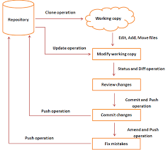

### Environment setup

First, you’ll need to [sign up for an account](https://github.com/) on GitHub.com. It’s as simple as signing up for any other social network. Let’s take a quick look at how to get a Github account setup and ready to use for projects on your Windows 8 machine.

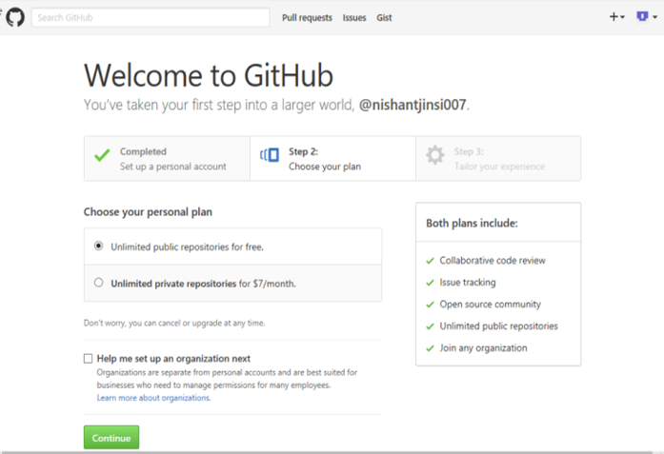

• To begin with, sign-in to [github.com](https://github.com/) or create a new account if you don’t already have one. Once done, you’ll see the welcome page as shown

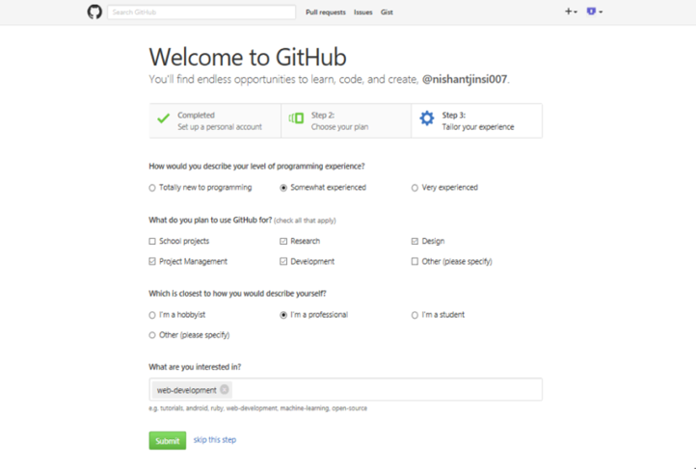

• After completing the 3 steps of setting up the Github account, Press the Submit key to create the github account associated with your email address.

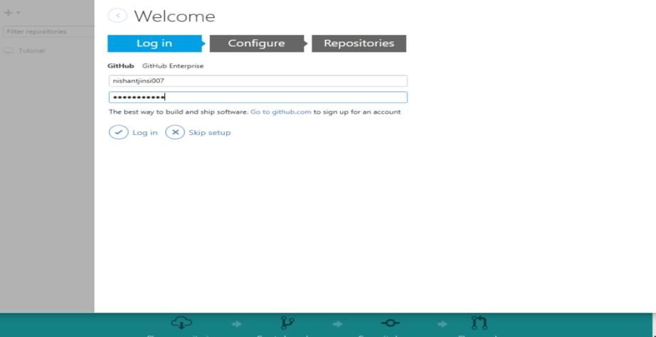

• Now, install github for Desktop from github.com and login to the application with your github account you created above.

### Create a repository :

Now that you’re all set up, it’s time to create a place for your project to live. Both Git and GitHub refer to this as a repository, or “repo” for short, a digital directory or storage space where you can access your project, its files, and all the versions of its files that Git saves.

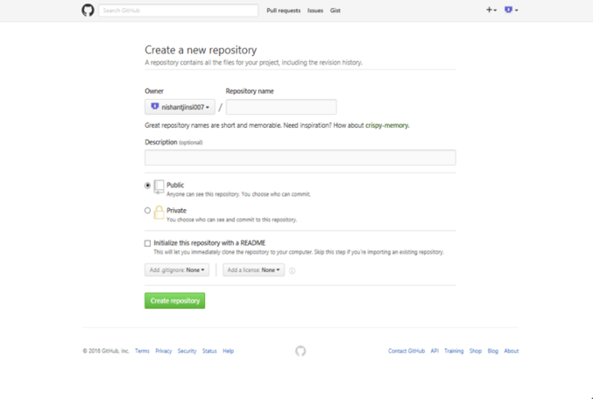

• First step is to create an online repository that is attached to your account. Go back to GitHub.com and click the tiny book icon next to your username. Or, go to the [new repository page](https://github.com/new) if all the icons look the same. Give your repository a short, memorable name.

• After creating that online repository, it is time for us to make a copy of that repo in our local computer, so we can make changes locally. So we need to actually mirror that repository we just made as a local directory and this is known as cloning a repository

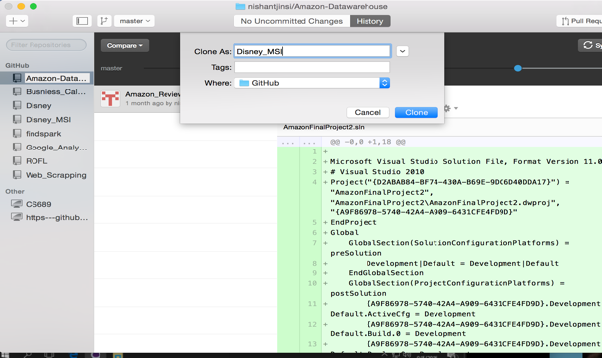 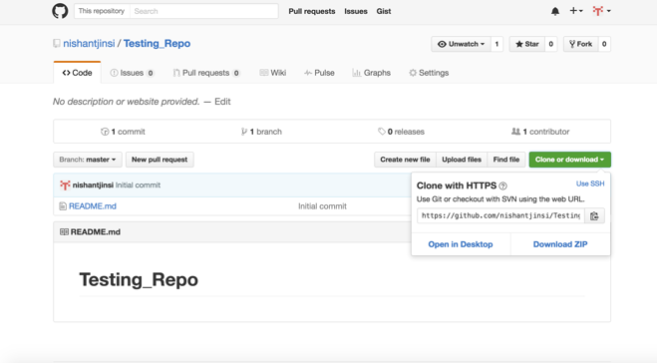

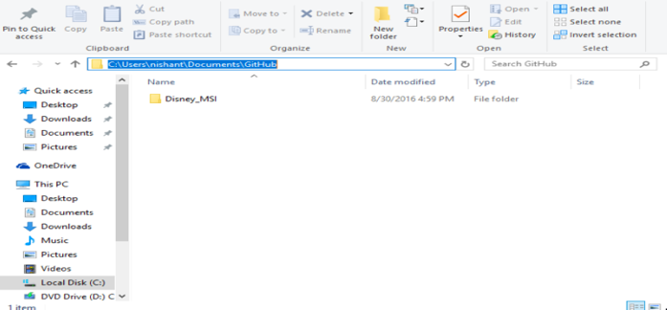

• Now, you will see a folder in your local computer with the name of the repository at the location you specified for your GitHub.

### Pushing changes to the Online Repository:

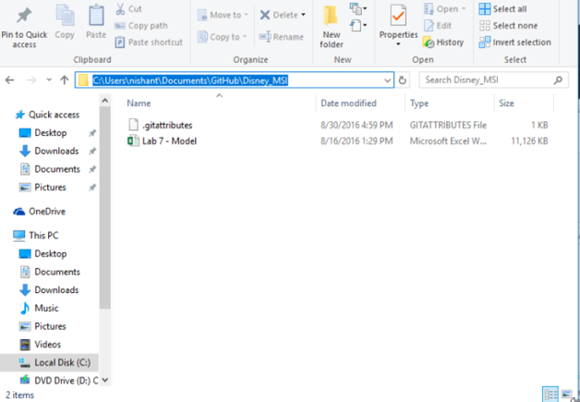

• Go ahead and add a new file to the project, using any text editor you like

Once you've added or modified files in a folder containing a git repo, git will notice that changes have been made inside the repo.

One of the most confusing parts when you're first learning git is the concept of the staging environment and how it relates to a commit.

A commitis a record of what files you have changed since the last time you made a commit. Essentially, you make changes to your repo (for example, adding a file or modifying one) and then tell git to put those files into a commit.

Commits make up the essence of your project and allow you to go back to the state of a project at any point

Now that your modifications are in the staging area, you can add some description of the changes you made and Commit to the master.

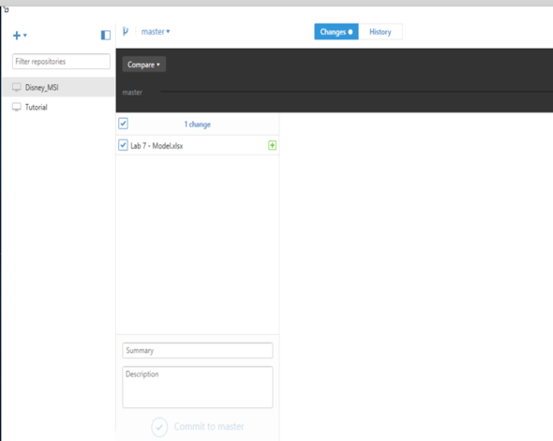 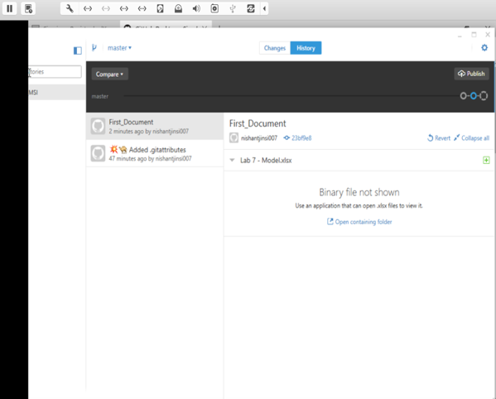

### Fork repository / Managing Branches:

**Branching** is the way to work on different versions of a repository at one time.

By default, your repository has one branch named master which is considered to be the definitive branch. We use branches to experiment and make edits before committing them to master

When you create a branch off the master branch, you’re making a copy, or snapshot, of master as it was at that point in time. If someone else made changes to the master branch while you were working on your branch, you could pull in those updates.

Have you ever saved different versions of a file? Something like:

• ABC-ROI.txt  
• ABC-ROI-v1.txt

• ABC-ROI-v2.txt

Branches accomplish similar goals in GitHub repositories.

**To create a new branch:**

• Go to your new repository

• Click the drop down at the top of the file list that says branch: master.

• Type a branch name, Test-Branch into the new branch text box.

• Select the blue Create branch box or hit “Enter” on your keyboard.

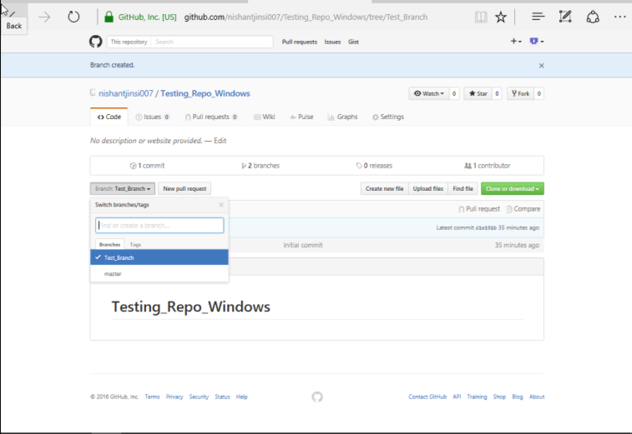

### Create a Pull Request:

A pull request (or PR) is a way to alert a repo's owners that you want to make some changes to their code. It allows them to review the code and make sure it looks good before putting your changes on the master branch.

• Click the **Pull Request** tab, then from the Pull Request page, click the green **New pull request** button.

• Look over your changes in the diffs on the Compare page, make sure they’re what you want to submit.

• When you’re satisfied that these are the changes you want to submit, click the big green **Create Pull Request** button.

Give your pull request a title and write a brief description of your changes.





### Merge your Pull Request:

In this final step, it’s time to bring your changes together – merging your secondary branch into the master branch.

• Click the green **Merge pull request** button to merge the changes into master



Note that this button won't always be green. In some cases it'll be grey, which means you're faced with a **merge conflict**. This is when there is a change in one file that conflicts with a change in another file and git can't figure out which version to use. You'll have to manually go in and tell git which version to use.

• Click **Confirm merge**. This will merge your changes into the master branch.

• Go ahead and delete the branch, since its changes have been incorporated, with the **Delete branch** button in the purple box.

### Stash Operation

Suppose you are implementing a new feature for your product. Your code is in progress and suddenly a customer escalation comes. Because of this, you have to keep aside your new feature work for a few hours.

You cannot commit your partial code and also cannot throw away your changes. So you need some temporary space, where you can store your partial changes and later on commit it. In Git, the stash operation takes your modified tracked files, stages changes, and saves them on a stack of unfinished changes that you can reapply at any time.

Now, you want to switch branches for customer escalation, but you don’t want to commit what you’ve been working on yet; so you’ll stash the changes. To push a new stash onto your stack, run the **git stash** command.

Use git stash when you want to record the current state of the working directory and the index, but want to go back to a clean working directory. The command saves your local modifications away and reverts the working directory to match the HEAD commit.

After you have resolved the customer escalation and you are back on your new feature looking for your half-done code, just execute the **git stash pop** command to remove the changes from the stack and place them in the current working directory.

The modifications stashed away by this command can be listed with git stash list, inspected with git stash show, and restored (potentially on top of a different commit) with git stash apply. Calling git stash without any arguments is equivalent to git stash save. A stash is by default listed as "WIP on branchname …​", but you can give a more descriptive message on the command line when you create on

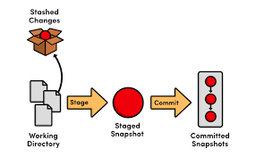

### Github vs Gitlab :

From my point GitHub and GitLab do have a lot of similarities. However there are some differences when comparing those two:

• **Authentication Levels**

With GitLab you can set and modify people’s permissions according to their role. In GitHub you can decide if someone gets a read or write access to a repository. With GitLab you can provide access to the issue tracker (for example) without giving permission to the source code.

• **Attachments**

In GitLab you can attach any file to any issue. You simply can’t do that inside GitHub.

• **Issue Tracking**

If you’re using GitHub issues you might think that it lacks some functionality. GitLab provides a powerful Issue Tracker that lets you change status and assignee for multiple issues at the same time.

[GitHub Issues](https://guides.github.com/features/issues/) lets you do similar things. And it’s a great issue tracker too. However, I personally prefer the interface of GitLab’s issue tracker over GitHub.

• **Integrations**

Both GitLab and GitHub offer a wide range of 3rd party integrations. Integrating your version control system with other application enriches your workflows and can boost productivity for your developers.

| **Features** | **GitLab** | **GitHub** |
| --- | --- | --- |
| **Pricing** | **Unlimited public and private repositories / unlimited public and private collaborators** | **Free for public repositories / Paid plans for private repositories** |
| **Code review features** | **yes** | **yes** |
| **Wiki** | **yes** | **yes** |
| **Bug & issue tracking** | **yes** | **yes** |
| **Private branch** | **yes** | **Yes (with paid plans)** |
| **Self-hosting** | **yes** | **Yes (with enterprise plan)** |
| **Popularity** | **100.000+ projects** | **35.000.000+ projects** |

GitLab is still the little brother of GitHub and has a long way to go if it wants to compete with GitHub on a user level. Nevertheless, GitLab is a great (and probably one of the best) alternatives to GitHub.